**Practical No 5**

**Aim: Study of Sequence Diagram**

A sequence diagram is the most commonly used interaction diagram. A sequence diagram simply depicts interaction between objects in a sequential order i.e. the order in which these interactions take place. The purpose of sequence diagrams describes how and in what order the objects in a system function. These diagrams are widely used by businessmen and software developers to document and understand requirements for new and existing systems.

**Notations of Sequence Diagram are:**

* **Actor****s**: a type of role played by an entity that interacts with the subject (e.g., by exchanging signals and data)
* **Lifeline**: A lifeline represents an individual participant in the Interaction.
* **Activations:** A thin rectangle on a lifeline) represents the period during which an element is performing an operation.
* **Call Message:** Call message is a kind of message that represents an invocation of operation of target lifeline.
* **Return Message:** Return message is a kind of message that represents the pass of information back to the caller of a corresponded former message.
* **Self-Message:** Self message is a kind of message that represents the invocation of message of the same lifeline.
* **Recursive Message:** Recursive message is a kind of message that represents the invocation of message of the same lifeline.
* **Create Message:** Create message is a kind of message that represents the instantiation of (target) lifeline.
* **Destroy Message:** Destroy message is a kind of message that represents the request of destroying the lifecycle of target lifeline.
* **Duration Message:** Duration message shows the distance between two-time instants for a message invocation.
* **Note:** A note (comment) gives the ability to attach various remarks to elements. A comment carries no semantic force, but may contain information that is useful to a modeler.

**A. Consider a vending machine. Consider the processes:**

**1.Buy a beverage: The vending machine delivers a beverage after a customer selects and pays for it.**

**2. Perform Scheduled Maintenance: The repair technician performs the periodic service on the vending machine necessary to keep it in good working condition.**

**3.Make repairs: The repair technician performs the unexpected service on the vending machine necessary to repair a problem in its operation. Load Items: A stock clerk adds items into the vending machine to add its stock of beverages.**

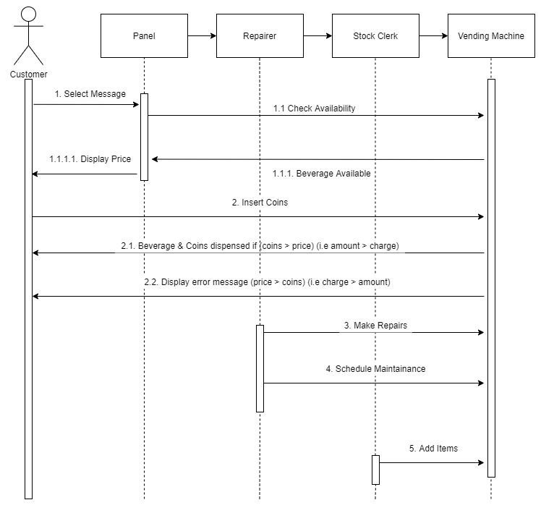

**B. The vending machine delivers a beverage after a customer selects and pays for it. The machine starts in the waiting state in which it displays the message “Enter coins”. When the customer inserts coins into the machine, the machine displays total value of money entered. The customer pushes a button. The machine dispenses a corresponding item and make change, if the cost of the item is less than the money inserted. If the cost of the item is greater than money inserted, the machine shows the message as “Insufficient money”. Draw the sequence diagram for above description.**

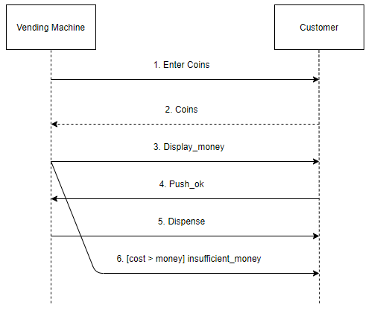

**C. Draw the sequence diagram to model “Withdrawal of cash Rs.25000 from the ATM”, depicting one transaction is limited to withdraw Rs. 20000.**

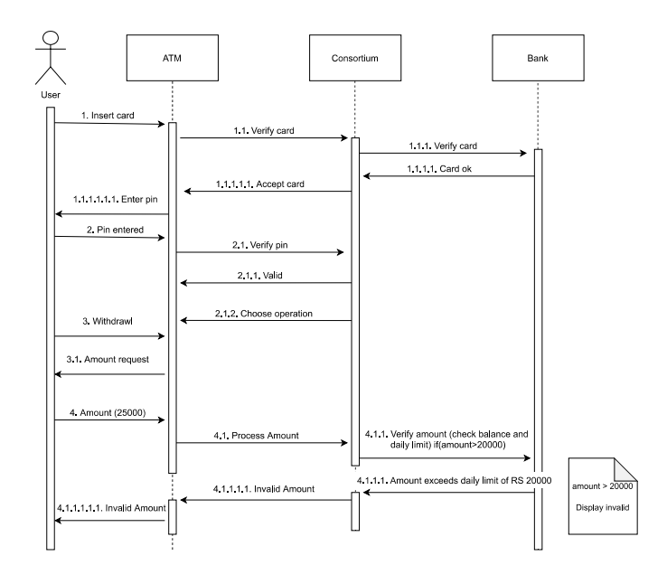

**Conclusion: We have studied the details about the Sequence** **diagram.**